OCR Computing H446: Component 3

Noah Stride

Bournemouth School

Centre Number: 55119

Candidate Number: 2129

# Table of Contents

Contents

Table of Contents 2

Section 1: Analysis 3

Problem Identification 3

Stakeholders 5

Existing Solutions 8

Limitations 17

Software and Hardware Requirements 18

Features and Requirements 20

References 24

# Section 1: Analysis

All solutions begin with an adequate analysis of the problem. This sets a framework for the solution to be built within, with clear expectations. This helps prevent resource consuming ‘feature creep’ that can lead to missed deadlines and the eventual derailment of a project. The analysis will begin by focusing on the problem itself, before considering the stakeholders and other solutions to the problem. Finally, a rigid specification will be set for the solution.

## Problem Identification

The chosen problem is that of simulating a computer processor and operation for the purposes of teaching computer science. The software should be appropriate for a variety of educational institutions and be considered on par or above the quality level of competing software. The problem is almost exclusively solvable using computational methods, and is amenable to being solved in this way for the following reasons:

### Complexity of the Simulation

A computer processor involves many complicated aspects and this makes it ideal for simulation as a piece of software. Working through a simulation by hand would be incredibly time consuming especially when considering the great speed at which modern processors operate. To simulate even a second of a modern processor would take years, if not decades. By simulating the processor using a modern computer, often capable of running at speeds beyond a hundred million operations a second, we are able to run it at speeds that will allow the user to test basic programs.

### Educational Requirement

The idea of the program is for it to be used to help teach and give people an understanding of a processor. It would be impossible for somebody to manually simulate a processor without having the prerequisite knowledge. By making it an interactive simulation, students will be able to try different things and visualize the various cycles within a processor. Processors can seem to be quite an abstract idea, so being able to interact with a simplification will enable people to grasp a deeper understanding.

### Controlled Environment

A processor is a relatively simple model and can be considered a closed environment. This is the opposite of more complicated systems such as weather and chemical reactions that are often subject to external influencing factors that are difficult to take account for. A tiny inaccuracy in a weather forecast will simply be compounded as the simulation runs. Because a processor is simple, and a closed environment, the simulation will remain accurate, making it an ideal thing to simulate using a computer.

### Ease of Visualization

A modern computer is equipped with graphics capabilities and this means it is possible to render images that will accurately represent the model. This graphics would simply and clearly explain the workings of a processor. This will also make the learning more engaging, as many people tend to be more interested by a visual explanation than a verbal one.

### Existing Infrastructure

Almost all computer science lessons are taught in classrooms with access to computers, which makes this problem incredibly amenable to being solved using a computational solution. This means the software will be able to be conveniently accessed by its key users, and that the staff will not have to book the room in order to use the software. Students may be able to use the software at home to expand their own understanding and revise.

## Stakeholders

Stakeholders remain one of the most important considerations in the development of software. Ultimately, if the software is not appropriate for its stakeholders then the project is a failure. It is important to note that, in many cases, it is impossible to please all stakeholders involved in a project, as many often hold conflicting requirements.

I have decided to primarily target educational institutions because the requirements of a technical professional will contrast too greatly with those of a student. Complexity of the processor must be abstracted to an understandable level, but by doing this valuable information to a professional is lost. Simulating a modern x86 processor is also beyond the scope of my own personal understanding, as the instruction set has grown significantly more complicated from its conception.

### School Management

The bureaucratic element of many organizations is easily ignored when it comes to the production of software, as they will not be final end-users of the software. However, software must still meet many requirements produced by the management of any organization in order for it to be adopted.

|  |  |
| --- | --- |
| User Requirements | Justification |
| Affordable | Software must be deemed economically viable for an organization to adopt it. This does not only cover the cost of purchasing software, but also support agreements and the time as well as financial cost of training the users. |
| Secure | Software must not present an additional risk to the system, intentionally or unintentionally. Vulnerabilities continue to be misused in software in order to gain a foot hold or escalate an attack, and it is the responsibility of the software developer to ensure this is not possible. This is not overly applicable to my solution because the software will not interact with any networks, and hence not present an attack vector. As my solution will be written in a high level language, it is unlikely the software will be vulnerable to memory attacks used for privilege escalation. |
| Compatible | Software will be more convenient for adoption by an organization if it is compatible with existing systems, both technically and bureaucratically. Software must be adapted to integrate with any hierarchies or procedures that are ingrained within an organization, as this means that integration will be a simpler, and cheaper, process. For our solution, this means the application should be of adequate depth to easily meet the teaching requirements of common Computer Science |

### Teaching Staff

Teachers represent the first of the user groups. The software must be apt to their needs, as they will spend the most time interacting with the software as it is used year on year with different classes. Software that does not adequately fulfil their requirements will become disused, with more appropriate solutions being found.

Mr. Albanozzo is a computer science teacher at Bournemouth School. He first suggested the project because he was frustrated with the limitations proposed by the Little Man Computer currently used to teach about processors and felt that a better version could be made.

|  |  |
| --- | --- |
| User Requirements | Justification |
| Simplicity and Demonstrability | Software must be simple to use and demonstrate. Software that is self-explanatory is easier to teach the use of, and reduces questions raised by students, allowing more time to teach the course content. Demonstrable software ensures that the UI is clearly visible and clear when shown on a projector and that actions are easily reproducible. |
| Accurate | The software must accurately represent the content of most computer science courses. If the software is misleading it may cause a lack of understanding of the course, which may be complicated to fix. On the other hand, if the software is accurate, it will further their knowledge and allow them to gain a deeper understanding of computer processor architecture. |
| Fast and Stable | The software must be responsive, load quickly, and not experience crashes or data corruption. Slow software holds up the learning process and crashes lead to the loss of work, both of which may require the intervention of the teaching staff to resolve, wasting valuable time. |

### Students

Students act as the primary target for the use of the software. They mostly share requirements with teaching staff, including the requirements for software to be fast and stable, for it to be compatible with their course, and for it to be simple enough to be quickly grasped. There are a few unique requirements.

Emilio is a run-of-the-mill computer science student at Bournemouth School. Whilst he performs well in most areas of the course, he struggles most with processors and assembly. He feels that Little Man Computer does not currently make many concepts needed at A-Level clear. He thinks he would be more easily able to understand the concepts if he had something to visualize how the data moved around the processor.

|  |  |
| --- | --- |
| User Requirements | Justification |
| Adaptable | Students have a varied range of abilities, the software should be able to offer multiple levels of difficulty to continue to keep stronger students engaged. Many pieces of software aimed at educational institutions fail to cater for all levels of student, and either are seen as too complex by weaker students and too simple by stronger students. |
| Clear | The student must be able to clearly see how data and instructions are moved around the system and how the important registers interact with each other. This will enable them to get a better understanding and help them to more easily remember the concepts as they can see them visualized. |

## Existing Solutions

Existing solutions provide great inspiration as to the required features of an application if it is to compete within the same market. Weaknesses of existing applications can be used to bolster your own and to improve the user experience significantly. However, it should be noted that not all pre-existing solutions may seek to solve the problem in the same way, with some focusing on alternative user groups

### ArmSim

ArmSim is a realistic simulation of an ARM RISC processor designed for testing assembly code designed for ARM processors before it is used on physical hardware. It provides a rather gray UI and provides a simple way for a programmer to view the running memory of the simulated processor. The UI is not particularly intuitive and the software is mainly aimed at professional programmers who will quickly become accustomed to their tools.

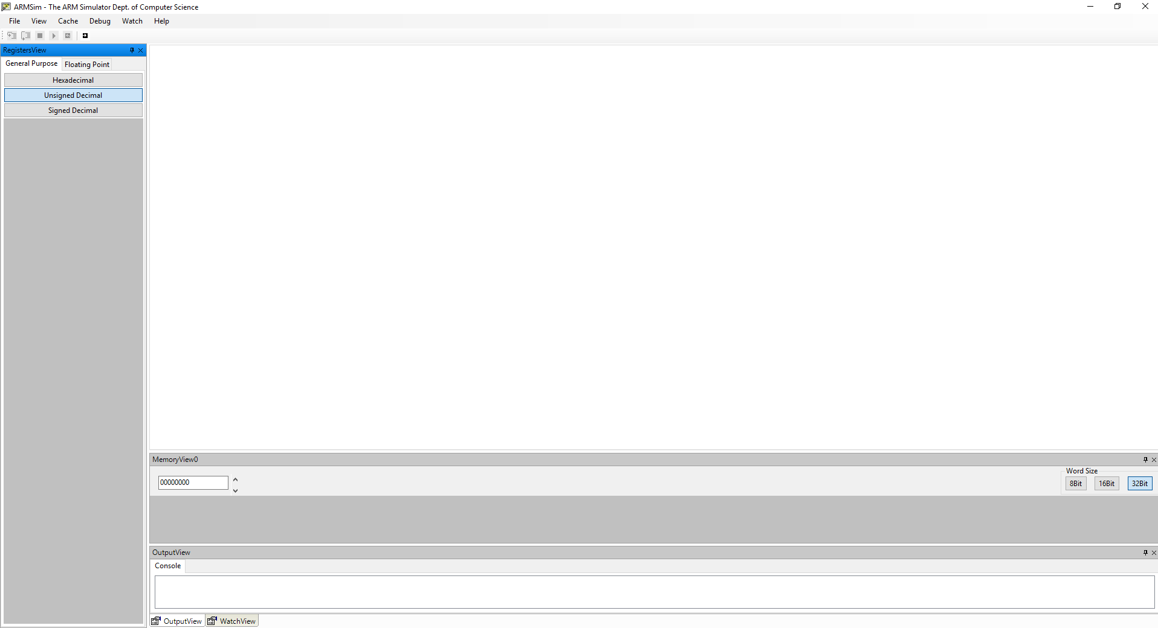

ArmSim does not provide an interface for writing code and instead allows a programmer to use an existing IDE they own to write the assembly and compile it to machine code before importing it. This is far more suitable for a professional who will already have an established workflow with their software and may have to use a certain IDE because of rules set by their management. It acts purely as a simulation of the processor, rather than trying to also act as an IDE.

It provides access to all of the registers that are found within an ARM processor as well as providing the ability to browse through the entire memory space, with a quick jump to an address feature. The stack is also provided as a separate sidebar to allow its contents to be better visualized compared to just browsing the memory locations. It provides the ability to step into and step through a program, or to run it as fast as the processor can. Data can be shown in the registers in decimal, hexadecimal or binary, depending on how comfortable the user is with each form.



The registers are demonstrated on the left side, with modified registers shown in red to clarify what has changed to the developer.

The simulation provides a one to one in-depth replica of an Arm processor, with the entire instruction set implemented with a fine level of detail. Software can be directly compiled to this instruction set from various language and can then be ran step by step through ArmSim. Whilst this level of detail and accuracy is essential to a seasoned programmer, it is unnecessary and perplexing for a student. Instruction sets and processors are far more complicated than the abstraction used by A-Level courses and ArmSim is likely to further confuse rather than help students.

ArmSim is provided as a compiled executable file. It is natively designed to run on Windows x86 64 or 32bit processors and the source code is not open. There has been some documented success at running it using the WINE (WINE Is Not an Emulator) platform on GNU/Linux and MacOSX.

|  |  |
| --- | --- |
| Feature | Justification |
| Fast simulation | ArmSim’s ability to simulate an ARM processor at close to real speeds is useful for developers wanting to test their programs properly. It allows more complex algorithms to be designed. |
| Simple access to memory | ArmSim provides an easy way to browse the memory and this is useful for students and developers trying to understand their program and debug any issues with their algorithms as they can see the changes to the memory clearly. |
| Detailed Simulation | ArmSim provides a comprehensively detailed simulation of an ARM processor. A balance will have to be struck between simplicity and complexity for my simulation as it will primarily aimed at as a teaching tool. |
| Display of values in multiple bases | ArmSim provides the user the ability to view values in decimal, hex and binary and this is beneficial as it will allow users to familiarize themselves with the common bases used within the CompSci world. This is also beneficial as some values only make sense in certain bases (i.e Instructions are clearer in binary where you can see the divide between Opcode and Operand) |
| Console window to provide feedback | The console window acts a simple way for the program to inform the developer of issues, as well as providing the output of the processor to the user. It is less intrusive than pop-up messages and can be scrolled back through to view historical changes. |

### Little Man Computer

Little Man Computer (LMC) is a CPU simulation designed for teaching about assembly and the workings of a processor. It can run within the browser and provides a graphical interface for interaction. Unlike ArmSim it provides a basic editing interface where a simplified assembly instruction set can be written and then compiled into machine code.

LMC provides a variety of features such as the ability to change the simulation speed. This is useful for people wanting to see more about the workings of a processor since they can slow it down and see it step through each part of the Fetch Decode Execute (FDE) cycle. Others may want to speed it up so they can see their code that they have written running more fluidly. There is quite a low limit to this speed and it can be frustrating when you have written a more complicated algorithm (for example to calculate prime numbers) and it takes a long time to execute.

The LMC provides an incredibly simplified model, with only a few core registers such as the PC, IR and MAR. The memory itself has only 99 addresses and each of these is restricted to an integer from 0 to 999. The instruction set is cut down to a few basic instructions and there is only a single memory addressing mode that the user is not even made aware of.

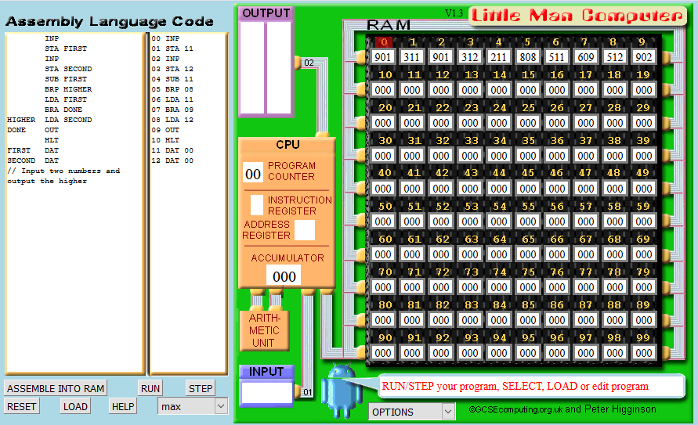

LMC further abstracts the processor by showing all numbers and commands as base ten integers rather than showing them as their binary equivalents. This may make it easier for a newer student to understand, as at first binary instructions may seem intimidating; however this does obscure the fact that an instruction stored in memory is composed of two distinct parts, the operator and operand.

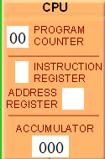Whilst LMC does simulate only a handful of registers, they are all clearly shown within their own part of the UI. This makes it simple to see how the values of the registers change as the FDE cycle completes, something that you may be examined on at GCSE and A-Level.

The fact that LMC can be embedded within the browser has advantages as well as limitations. One of the prime advantages is portability. Browsers act as a layer of compatibility and this means that LMC can run across different operating systems as well as processor instruction sets. This also means that the application does not need to be pre-installed, only a relatively modern browser is needed, and for the most part this is already present in most schools. The biggest limitation of this is processing speed. Modern browsers and the JavaScript engine add lots of overhead to execution and this restricts how fast it is able to simulate the processor. JavaScript is also a problematic platform considering its varied implementation across not only versions of browsers, but browsers themselves. This makes it hard to predict how it will behave when deployed across a wider user-base.

|  |  |
| --- | --- |
| Feature | Justification |
| Appealing Interface | An appealing interface makes the program more attractive to those learning to program, whilst seasoned developers are more used to more plain design. An appealing interface will also be easy to work with and not frustrate users. |
| Ability to adjust speed | The ability to adjust speed is useful for almost all users, as at lower speeds it is similar to step-through debugging. At higher speeds, the user can examine the overall effectiveness of the algorithm, especially more complicated ones. |
| Simplicity | LMC simplifies the architecture of a processor to a point where it is understandable, however my program must go further in ensuring that it also provides enough depth, which LMC does not. |
| Simple Assembly Editor | LMC provides a useful interface for writing the assembly, unlike ArmSim, and this allows the user to quickly make changes and retranslate the code rather than having to switch out to another application and reload the code. This editor could be taken further to help the user. |
| Values of registers clearly displayed | The values of each register, and how they connect to each other, are clearly displayed (for example the accumulator is show connected to the ALU) and this helps users get a better understanding of how a processor works. |

### Assembly Training Program (ATP)

Assembly Training Program is an old windows application designed to teach assembly at higher levels. The application does not run on newer versions of windows, however it comes with comprehensive documentation that outlines the specifics of the simulated processor and I will instead examine this.

The ATP processor is known as the BEP/16 which is a hypothetical 16 bit processor based roughly on the popular Intel 8086 microprocessor platform, the processor from which the x86 instruction set still in use today derives from. This makes it still an accurate representation of how a modern processor works, as even though major changes have been made over the years, the base instruction set has remained primarily the same.

The BEP/16 provides 10 general purpose registers as well as a full 16 bit Program Counter, Stack Pointer, Flag Register and Overflow register. The 16 bit nature of the Program Counter limits the total RAM size to at most 64K addressable bytes, however the processor also offers another 16K bytes of stack, both of which are accessed in 2 byte words. This configuration is incredibly flexible, with the general purpose registers allowing more complicated programs to be written by students. The amount of RAM is more than enough for the purposes of most students.

The flag register provides multiple useful flags. This includes the carry bit, zero flag, sign flag as well as an overflow flag. Each flag takes up a single bit of space and are updated as calculations are carried out to reflect the current state of the processor. For example, the zero flag will be set if the result of an operation in the ALU is 0, and be reset back to false if another operation takes place that produces a different result.

The 16 bit nature of the processor provides more than enough resources (65,535 integer values) for most calculations, with some arguing that it could be enough to actually overcomplicate matters. However, the next natural step down would be an 8 bit processor, which would be incredibly restrictive in only being able to hand unsigned integers of 0-255. A 32 bit processor would be greatly in excess of the requirements of the users and introduce new challenges in terms of the UI, as more data would have to be displayed.

The instructions are provided in the typical MODE-OPERATION-OPERAND format, with 2 bits for the memory mode, 6 bits for the operation (providing up to 64 possible operations), 4 and 4 bits for selecting the registers used in the operations with the remaining 8 bits used for the operand. This format is more complicated than that used in the Little Man Computer but provides much more flexibility to the programmer, certainly making it more appropriate for universities and sixth-forms as opposed to GCSE level.

Unlike the Little Man Computer, ATP provides access to a variety of addressing modes. This is useful as at A-Level addressing modes are taught as part of the specification, yet are missing from a common teaching tool. The BEP/16 offers 7 addressing modes, with not all of these available for all instructions. Direct, Indexed and Indirect are exclusively reserved for the STR and LDR register-RAM transfer commands.

ATP also provides a rudimentary assembler with preprocessing features. This allows the user to write assembler rather than the direct machine code that is executed by the simulated processor. The assembler is little more than rudimentary, providing a few simple #DEF operations allowing constant values to be easily set and reused within the program. Registers may also be provided an alias. This seems like a useful feature, even for new programmers, as it will allow them to write code that is more self-explanatory and easily understood by others.

Software Interrupt Routines (SWI) are also provided by the BEP/16 infrastructure and act as a way for the programmer to interact with an user. Calling an SWI triggers a context switch, with all the registers being pushed onto the stack bar R0 which is used for communication between the program and the interrupt routine. Four software interrupts are provided: getInt, putInt, getChar, putChar. These are a particularly useful part of the simulation that could have just been abstracted, however instead they have been implemented properly and this means that the user can get an understanding of how the software interrupt process works, something that is required at A-Level.

|  |  |
| --- | --- |
| Feature | Justification |
| Powerful instruction set | Allows the user to create more than just rudimentary programs and instead create more fully functioning programs. |
| Implementation of ISRs | Interrupt Service Routines are not defined in Little Man Computer but are required by the A-Level specification, the context-switching process could be clearly demonstrated. ISRs are also a useful way of the processor serving the requirement for input and output. |
| Appropriate Simplicity | Assembly Training Program strikes a careful balance in ensuring that the user is not overwhelmed with an entirely complete instruction set, instead only the core, most important, parts are implemented. |
| Multiple addressing modes | ATP provides multiple addressing modes to the user, something that is mentioned at A-Level, and this allows the user to write more efficient programs with, for example, indexed addressing. |
| Assembler with directives | The assembler within ATP supports useful directives for the developer. These speed up the programming process and allows constant values to easily be changed across the application. |

## Limitations

No project is without a scope and it is always important to have realistic expectations of what an application will be able to within the deadline and budget. The program will target the education market and I have drafted several relevant limitations to the project.

### Direct execution of compiled code

Whilst ArmSim provides the ability to run native code that has been compiled by GCC and other similar industry compilers, our application will not. There is limited use of this feature to students and it would require implementing the entirety of a comprehensive instruction set (e.g x86_64 with 981 base instructions and 3683 variations of those [1] ), which is simply unrealistic within the deadline set.

### Ability to run on a wide variety of platforms

For my application I will most likely be using a .net based language and these executables do not natively run on operating systems other than Windows. Whilst it is possible to port them to compile with Mono (A .net alternative for GNU/Linux), this is simply not possible within the deadline set for the project.

### The entirety of an existing instruction set

Most of an existing instruction set will not be used by students day to day and to implement it within the timeframe set for the project would be unrealistic. Instead I will try to make my own instruction set in the style of x86 to allow people to get the gist of existing instruction sets

### Alternative architectures

My software will simulate a Von Neumann-esque processor. It would be too time consuming to implement multiple different architectures and would provide little advantage as students are not required to understand the exact workings of other architectures.

## Software and Hardware Requirements

It is reasonable to set out expectations for the kind of hardware and software required to be able to run my application. Choosing the frameworks and language to be used is often difficult, as no language is capable of dealing with all problems and choosing the wrong one can lead to more time being spent trying to work around a problem.

### Software

I have decided to choose C# with the .Net Framework as the language to use for my application development. Whilst it is not my favorite or most comfortable language, it is well suited to the problem for a variety of reasons:

#### Targeted Desktop Development

C# and the .Net Framework (Visual C#) was originally targeted at desktop development and provides a wide variety of useful classes for visual components (buttons, text boxes, panels etc) with a unified styling. This will allow me to produce a professional looking application quickly.

#### Fast

Once compiled C# is much faster than interpreted languages such as Python. This means it will be able to simulate more processor cycles each second, giving the user more flexibility. Of course it is not as fast as C++ and other lower level languages, but this is at the cost of usability when trying to rapidly prototype an application.

#### Type Safe

C# provides strict static typing as well as tight access control and this makes it an incredibly type safe language. This helps the developer, especially in larger projects, produce an overall more stable and predictable program that is not vulnerable to unexpected issues caused by dynamic types and casting. Stability is an incredibly important aspect of any commercial application, especially those where a user could lose work if the application crashes.

#### Comprehensive Tooling

Microsoft provides a comprehensive set of tools through its Visual Studio IDE that includes advanced debugging with stepping and watching, static code analysis and a WYSIWYG editor. This allows the application to be rapidly produced with easy results, which is important considering the short deadline on the project.

### Hardware

Hardware specification is something of a dark art as it can be hard to predict exactly how an application will perform until you have benchmarked it. However, rough guidelines can be drawn up from what we would expect from the average C# .Net application. Fortunately most schools provide computer science labs with higher specification machines so that they can run virtual machines etc and this provides us more room to work within.

Minimum requirements:

* Dual Core processor at 2.6 Ghz
* 4 Gigabytes of RAM
* Free disk space of 10GB
* Integrated graphics capability

Recommended requirements:

* Quad core processor at 3 Ghz
* 8 Gigabytes of RAM

## Features and Requirements

### Essential Features

|  |  |
| --- | --- |
| Feature | Justification |
| Instruction set with enough depth for complex programs | My program must be able to allow students to challenge their own abilities by designing more complicated programs, software such as LMC simply does not have the depth required to allow students to stretch themselves adequately. |
| Simple and easily grasped user interface | The user interface must be quick to understand for new users. The interface should be accessible to a wide range of understandings and not confuse new users by presenting too much information. |
| The ability to modify the speed of the simulation | The user must be able to change the speed of the simulation in order to switch between wanting to understand the Fetch-Decode-Execute cycle on the microscopic level to wanting to write more complicated algorithms. |
| Basic editor for Assembly with SCA | A basic editor for my assembly must be included within the program with static code analysis. This analysis will allow the software to prompt the user when a mistake has been made before any attempt has been made to translate it. This will allow the user to develop code quicker, as they will not need to wait to discover issues. |
| Accurate simulation of a processor according to the A-Level and GCSE specifications. | The processor should be designed to demonstrate the entirety of a processor according the A-Level specification with adequate depth to allow students to push themselves. There is no need for the processor to perfectly simulate an existing, more complicated, architecture. |
| A selection of example programs | Example programs for common algorithms should be included to demonstrate the abilities of the simulation as well as to help teach the user how to use the provided assembly. It would also be useful for users to learn how many of the core algorithms to Computer Science work. |
| Ability to save and restore the state of the processor | The user should be able to save the processor and the code currently stored in it and then restore this at a later date. |

|  |  |
| --- | --- |
| Requirement | Justification |
| Sliding scale for adjusting the speed of the simulation. | A sliding scale is easy for a user to adjust, and precise values are not required. It is intuitive and simple to understand, rather than requiring the user to enter a specific clock speed to use. |
| Visualization of the register contents of the PC, MAR, CIR, MDR, ACC | These registers are an important part of the specification and understanding of how a processor works, therefore they should be visually distinct from the general purpose registers. This makes the interface easy to understand. |
| Example Bubble Sort and Binary Search | Bubble sort and Binary Search are of significant complexity to aptly demonstrate the abilities of the processor and instruction set. They are also key algorithms included in the Computer Science course, so users may already be familiar with them. |
| The editor must highlight unknown mnemonic, as well as cases where the mnemonic is not followed by the correct amount of parameters. | This simple analysis of the code written by the user will sufficiently catch a majority of mistakes made and assist them in writing correct assembly first time. It will not be too difficult to implement. |
| TO BE EXPANDED |  |

### Requirements

### Success Criteria

|  |  |
| --- | --- |
| Success Criteria | Justification |
| Sliding scale should correctly adjust the speed of the simulation from 1Hz to at least 100Hz | 1 Hz to 100 Hz provides an adequate range of test values to ensure that the simulation correctly scales to the different speeds. There shouldn’t be much need from users to run it faster. |
| The contents of the PC, MAR, CIR, MDR, ACC should be displayed accurately and real-time, ensuring the view and model in sync. | It is important that elements of the interface accurately represent the state of the model being simulated in the back-end. |
| The contents of the PC, MAR, CIR, MDR, ACC should be adjustable via the interface and this adjustment should have the correct effect on the simulation. | Bubble sort and Binary Search are of significant complexity to aptly demonstrate the abilities of the processor and instruction set. They are also key algorithms included in the Computer Science course, so users may already be familiar with them. |
| TO BE EXPANDED |  |

# Section 3: Development

I wrote code, fucked bitches, and got paid. This application is the result of 3424g of Caffeine, 64g of Mandy and at least 4 lines of coke.

## Wire Framing the Classes

Referenced by Git Commit (f05d82f1a0d4e1248d1af2bb9d774f7d3dc6c303)

I started off development by creating a handful of classes and wire-framing their properties and methods. Whilst the code written would not reflect the final implementation of the classes, it would be enough to see how it would fit together and evaluate how effective the structure would be.

The first class I created was the processor class. This class would consist of other components and tie them together in a hierarchal structure. The processor class would act as the model that would eventually be interacted with and displayed through the view layer. By passing the processor to the sub-components, they would be able to easily access other components. This technique is clear within the constructor of the processor class:

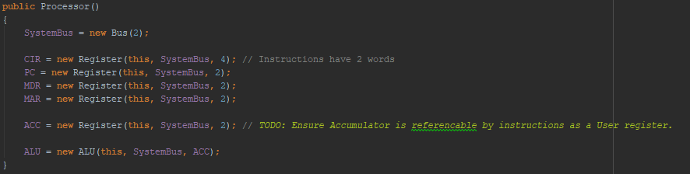

Here you can see the instantiation of a variety of registers, linking them to the processor, system bus and specifying their width in bytes.

The processor works on an event-driven model, with each Clock tick triggering three events ClockRising, ClockFalling and UpdateUI. These events are listened to by the individual components which then act accordingly. I decided to use events as they provide a flexible way of triggering methods across a range of dissimilar objects.

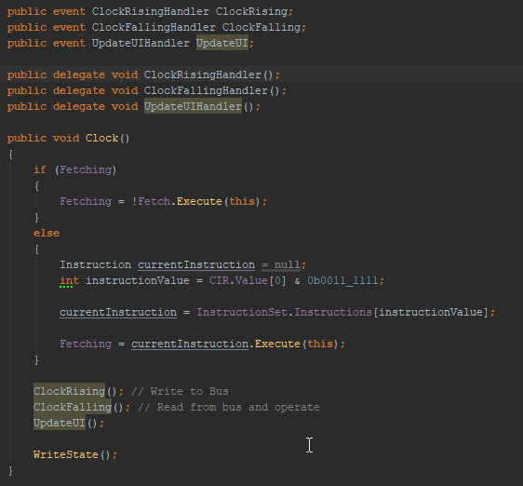

Here the three events and their corresponding delegates can be seen. These are scoped as public because the other classes (the view and the components) also need to be able to hook onto these events.

A rough implementation of the Clock method can also be seen. The Fetching flag simply refers to if the application is in the Fetching or Executing part of the cycle. The instruction class provides a simple Execute method which returns True or False whether or not the instruction has completed each of its micro-code steps, this will become clearer later in this section when the Instruction class is shown.

The final part of the processor class is the hard encoded Fetch instruction. Whilst the instruction set will be inter-exchangeable, the Fetch instruction is not available to the user and instead used only internally by the processor. I drafted the fetch instruction based on the specification I processed for the EDP.

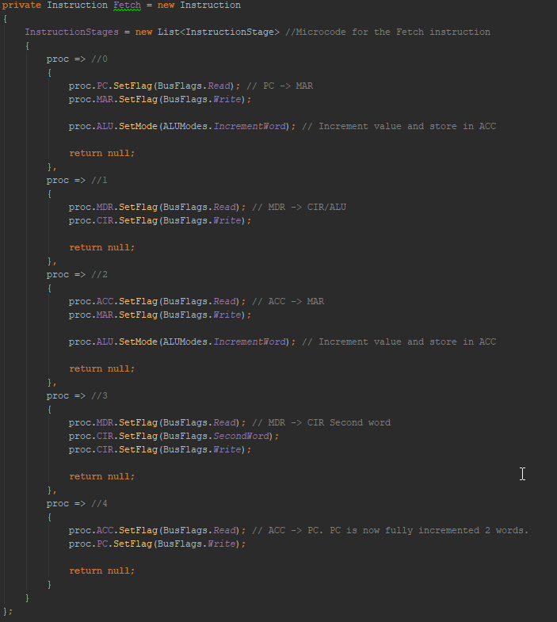

Each stage in the array represents a microcode instruction that sets the flags on each of the registers and components. The Fetch instruction is interesting because it has to retrieve two words from the memory. This means two memory operations are completed, one for the first word and one for the second. A rough comment is included for each step that shows the transfer of data between registers.

I then had to write the basic implementation for the registers. Like all other bus components they would be designed to write to the bus on the rising edge and read from the bus on the falling edge. This emulates an actual system where it takes time for the signal to physical propagate across the bus.

References

|  |  |
| --- | --- |
| [1] | S. Heule, "How Many x86-64 Instructions Are There Anyway?," 7 March 2016. [Online]. Available: https://stefanheule.com/blog/how-many-x86-64-instructions-are-there-anyway/. |